# Assignment 1 5%

Introduction to Oracle 12c SQL and DB concepts

## Answers Due Date: October 5, 2017 midnight extended October 6 midnight

**Part 1** Maintaining and redesigning an existing database (2 %)

Use your database created from the SQL Developer Tutorial Script (LAB 1). You must use your server account on BTACS database and perform all queries using your own account. This data base should have three tables.

books ( book_id, title, author_last_name, author_first_name, rating)

patrons (patron_id, last_name, first_name, street_address, city_state_zip, location)

transactions (transaction_id, patron_id, book_id, transaction_date, transaction_type)

Use the existing database to do the following:

1. **Adding new data (DML):**
   1. Add a new book to the BOOKS table: add **your favorite book** (add a high rating ☺).

INSERT INTO L1_BOOKS

(

BOOK_ID,

TITLE,

AUTHOR_LAST_NAME,

AUTHOR_FIRST_NAME,

RATING

)

VALUES

( 'Z0001', 'You are not A Gadget', 'Lanier', 'Jaron', 10 );

* 1. Borrow your favorite book. Use yourself as a patron (added in Lab1). Return your favorite book.

--To borrow transaction code = 1

INSERT INTO TRANSACTIONS (PATRON_ID, BOOK_ID, TRANSACTION_DATE, TRANSACTION_TYPE)

VALUES

((SELECT PATRON_ID FROM patrons WHERE first_name = 'Mila'), 'ZCCCC', SYSDATE, 1);

--To return transaction code = 2

INSERT INTO TRANSACTIONS (PATRON_ID, BOOK_ID, TRANSACTION_DATE, TRANSACTION_TYPE)

VALUES

((SELECT PATRON_ID FROM patrons WHERE first_name = 'Mila'), 'ZCCCC', SYSDATE, 2);

* 1. List **the last transaction** (all columns) for **your favorite book.**

Print the SQL queries for a-c and the result for c.

-- using subquery to find last transaction

SELECT *

FROM L1_TRANSACTIONS

WHERE TRANSACTION_DATE = (SELECT MAX(TRANSACTION_DATE)

FROM L1_TRANSACTIONS

WHERE BOOK_ID ='Z0001')

AND BOOK_ID = 'Z0001';

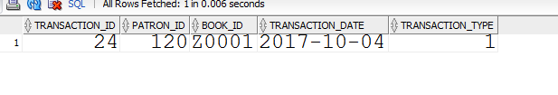

1. **Adding new columns (DDL):**
   1. Write an SQL statement to add a new column DOB to the PATRONS table. Print the query.

ALTER TABLE L1_PATRONS

ADD (DOB DATE);

* 1. Write an SQL statement to add LAST_MODIFIED and MODIFIED_BY columns to the PATRONS table. The LAST_MODIFIED column will have the server date and time and the MODIFIED_BY will have the USER name.

ALTER TABLE L1_PATRONS

ADD (LAST_MODIFIED_DATE DATE DEFAULT SYSDATE,

MODIFIED_BY VARCHAR2(15) DEFAULT USER);

Print the DDL statements for a and b.

1. **Changing data (DML):**
   1. Add DOB to an existing patron (yourself). Use the TO_DATE function for the DOB.

-- please note the my patron id is 120

UPDATE L1_patrons

SET DOB = to_date('1999-12-20', 'YYYY-MM-DD')

WHERE PATRON_ID = 120;

* 1. Add another patron with all data (including columns added in 2b).

-- please note TO_DATE also DATE function

INSERT INTO L1_PATRONS

(

PATRON_ID,

LAST_NAME,

FIRST_NAME,

STREET_ADDRESS,

CITY_STATE_ZIP,

DOB

)

VALUES

(

PATRON_ID_SEQ.nextval,

'John',

'Smith',

'TRU Way',

'Kamloops',

TO_DATE('1977-10-09', 'YYYY-MM-DD') );

-- please note location could be null, and the last modified date and modified by have default values

* 1. List the patrons (Last_modified, patron_id, last_name, first_name, DOB) whose data were added/modified **within last 10 days** (use SYSDATE as today’s date). Use ISO standard for LAST_MODIFIED including local time. Use only the year for the DOB (YYYY). Sort the results by transaction date (newest transactions first).

Print the SQL queries for a-c and the result for c.

SELECT

TO_CHAR(LAST_MODIFIED_DATE, 'YYYY-MM-DD HH24-MI-SS'),

PATRON_ID,

LAST_NAME,

FIRST_NAME,

EXTRACT(YEAR FROM DOB)

FROM L1_PATRONS

WHERE LAST_MODIFIED_DATE > SYSDATE -10

ORDER BY LAST_MODIFIED_DATE; -- note: 10 is in days

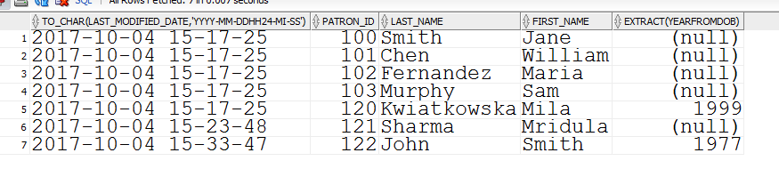

**Part 2** Data Modeling for the TRU Sleep Clinic (2 %)

Use the following information/knowledge to prepare data requirements for the TRU Sleep Clinic.

TRU sleep clinic runs a special study on blood pressure (BP) and sleep disorders (specifically obstructive sleep apnea). The following data has to be kept for each patient: patient ID, gender, DOB, date/time of assessment, weight, height, BMI (calculated from weight and height), blood pressure: systolic and diastolic BP, antihypertensive medication (yes/no). The data for the weight, height, BP, and AH medication are recorded once a month. The weight and height should be stored using the International System of Units (SI standard/ metric).

1. Create a **Logical Data Model** (use Relational Model) for the above study: list the relations with attributes, PKs, and FKs. For each attribute provide a short description (meaning), domain, standard for units/representations. Patient ID is a unique integer number assigned by the Clinic Coordinator. Gender should allow for undeclared values (represented by ‘U’) and unknown (missing values) as NULL.

List the relations with indicated PKs (underlined) and FKs (in italics).

PATIENT(PATIENT_ID, GENDER, DOB)

ASSESSMENT(ASSESSMENT_ID, ASSESSMENT_DATE_TIME, WEIGHT_KG, HEIGHT_CM, BMI, SYSTOLIC_BP, DIASTOLIC_BP, AH_MEDICATION, *PATIENT_ID*)

PATIENT_ID number assigned by the clinic coordinator NOT NULL primary key

GENDER char(1) Domain = {M, F, U} NULL allowed

DOB date Valid date (time will be set to 00)

…

1. Using your Logical Data Model, create a **Physical Data Model**. Prepare a **DDL script to create the table(s) with the appropriate constraints (entity, referential integrity, and domain)**. The BMI column should be defined as a virtual column (value generated automatically based on other columns). Calculate the Body Mass Index (BMI) of the patients at the time of the study. Use only as many significant digits as is justified. **BMI = weight(kg)/height(m)2**

**Print the DDL script.**

**CREATE TABLE patients**

**(patient_id NUMBER (10) PRIMARY KEY,**

**gender CHAR(1)**

**CHECK (gender IS NULL OR gender IN ('M','F','U')),**

**DOB DATE)**

**CREATE TABLE assessments**

**(assessment_id NUMBER (10) PRIMARY KEY,**

**assessment_date_time DATE NOT NULL,**

**weight_kg NUMBER (3) NOT NULL,**

**height_cm NUMBER (3) NOT NULL CHECK (height_cm > 10),**

**systolic_bp NUMBER (3) NOT NULL,**

**diastolic_bp NUMBER (3) NOT NULL,**

**AH_medication CHAR(3) CHECK (AH_medication IN ('YES', NO')),**

**bmi AS (weight_kg/((height_cm/100) * (height_cm/100))),**

**patient_id number (10) references patients(patient_id));**

To supply a value for DOB column you can either use the TO_DATE() function or standard ANSI/ISO date literal e.g., **DATE '1999-09-29' (note the date format must be YYYY-MM-DD)**

1. Using your table(s) created in 2 perform the following tasks:
2. Write SQL DML statements to add **3 patients**. For each patient add data for **3-4 clinical assessments.**

**INSERT INTO patients VALUES (1,'F', DATE '1999-09-29');**

**INSERT INTO patients VALUES (2,'M', DATE '1965-08-29');**

**INSERT INTO patients VALUES (3,null,DATE '1979-06-01');**

**--just an example**

**INSERT INTO ASSESSMENTS**

**(**

**ASSESSMENT_ID,**

**ASSESSMENT_DATE_TIME,**

**WEIGHT_KG,**

**HEIGHT_CM,**

**SYSTOLIC_BP,**

**DIASTOLIC_BP,**

**AH_MEDICATION,**

**PATIENT_ID**

**)**

**VALUES (1212,SYSDATE, 68, 175, 120, 80,'YES', 3 );**

1. Write an SQL query to list the patients and their age at the time of each assessment. List the patient ID, age, and assessment date.

**PLEASE NOTE: MULTIPLE ANSWERS POSSIBLE**

-- rounding or truncating to the nearest integer value

-- the difference between two dates is in days

SELECT PATIENT_ID

,ROUND(((ASSESSMENT_DATE_TIME - DOB)/365)) "Age"

,ASSESSMENT_DATE_TIME "Assessment Date"

FROM ASSESSMENTS NATURAL JOIN PATIENTS;

select PATIENTS.PATIENT_ID

,ROUND(((ASSESSMENT_DATE_TIME - DOB)/365)) "Age"

,ASSESSMENT_DATE_TIME "Assessment Date"

from ASSESSMENTS join PATIENTS

on ASSESSMENTS.PATIENT_ID = PATIENTS.PATIENT_ID;

select P.PATIENT_ID

,ROUND(((ASSESSMENT_DATE_TIME - DOB)/365)) "Age"

,ASSESSMENT_DATE_TIME "Assessment Date"

FROM ASSESSMENTS A, PATIENTS P

where A.PATIENT_ID = P.PATIENT_ID;

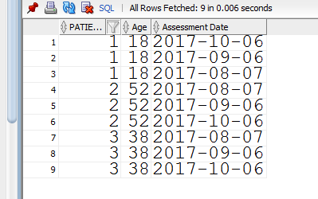

1. Write an SQL query to list all patients’ BMI characteristics: min, max, median, mean, and standard deviation.

-- Note rounding function

SELECT ROUND( MIN(BMI),1) "Min" ,

ROUND(MAX(BMI),1) "Max" ,

ROUND(MEDIAN(BMI),1) "Median" ,

ROUND (AVG(BMI), 1) "Mean" ,

ROUND (STDDEV(BMI),1) "STD"

FROM ASSESSMENTS;

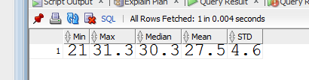

**Print the SQL statements for a, SQL queries and results for b and c.**

**Part 3** Research (1 %)

**Using online documentation for MySQL 5.7 and Oracle 12c, answer the following questions:**

1. Compare and contrast the methods for creating an **automatic unique identifiers** in each DBMS. Put your answer in a short point/paragraph/table format. List references (at least one source in APA style). Check the library for APA style guides (ask the librarians), for example <http://libguides.tru.ca/APA>
2. Compare and contrast the **storage of date, time (precision), and time zones.** Specify the data types for storing date, time, and time zones in each DBMS. How dates are stored internally in each DBMS? What is the maximum range for dates? Prepare your answer in a table format. List references (at least one source in APA style).

**Submission of the Assignment**

Please create a pdf document with your answers. Make sure that the queries are printed using a **monospaced font (e.g., Courier font)** and are **properly formatted** (see textbook). Create a pdf document and upload the document to the BLearn. Indicate the Part and Problem number for your answers. Your document should have a title page with your name, student number, course title, and date. Upload pdf file.